Dots and Boxes
Calvin Chan and Adam Tucker

Abstract—This paper reviews the applications of artificial intelligence to a game called dots and boxes. First, we discuss the goal of the project and the capabilities of our AI. It then summarizes how to play the game, the code to implement it, and the AI’s functionality. The paper touches on some minor surprises that came up when designing our project. Following this, we display the results of our code and the techniques our AI successfully applies. Finally, we conclude our project with how efficient our AI is currently and ways to improve it.
Keywords—Artificial Intelligence, greedy, minimax

Introduction
The goal for our final project was to design a program using Artificial Intelligence to play and beat the player in a game of dots and boxes. The AI needed to successfully examine the current state of the board and make optimized moves based on the player’s moves. This was especially difficult to figure out due to the many possible moves the player could make; however, after the beginning stages, the potential number of “safe” moves became more manageable. After making sure the AI didn’t give any points away to the player unintentionally, our next mission was figuring out which move would cost the AI the least amount of points and increasing its chances of winning - minimax. This task meant the AI was required to foresee how many points it was forfeiting.

Framework

Game Description
Dots and Boxes is a game typically played by two players; however it can be played by as many as you want, depending on the board size. For this project, we will only be implementing a two player program where the user plays against an artificially intelligent computer.
The game starts off with a set number of dots to form a rectangular grid. Players take turns connecting two adjacent dots either vertical or horizontal to form an edge. Players score points whenever they create a box with four edges. Whoever places the last edge to form a box receives one point and can go again until they place an edge that doesn’t result in a box. The game is finished when no more edges can be placed on the board. Winner is determined by the player with the most points.
Generally, strategies involve not selecting any third edges before the whole board is constructed to avoid giving away free points, double-cross strategy, and giving up smaller chains first in order to obtain longer chains which give more points.

Coding
We coded the program in C++. We decided to store the Dots and Boxes board as a class specifically for the dots to mark the edges and indicate if a box is created. In the 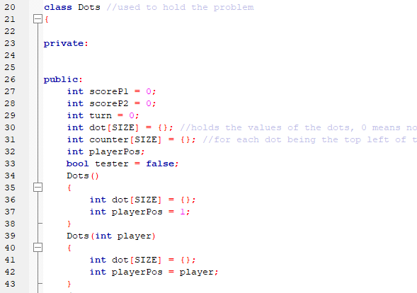beginning steps, we had to figure out how to implement each edge placement, either hold all the edges in a data structure and use a 1 for edge placed there or 0 for no edge or use dots to mark the position of edges to the right and down of each dot. The second method takes account of each edge vertical and horizontal. The approach we went with was storing the edges based on the dot value. First, the player selects the dot to attach an edge to, counting left to right, top to bottom, stored in an array. Next, the player selects right or down. If right was selected, 1 was stored in that dot value. If down was selected, 2 was stored in that dot value. The value 3 is stored if the dot has both right and down edges activated.
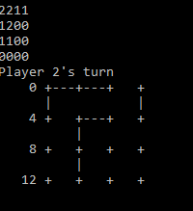
Next, after edge implementation, we were tasked with translating it to the dots user interface we currently have now. First, we had to print out the same number of dots as the two by two matrix created by SY and SX. Dots were marked as (+) which was the simplest because it was located in the middle of the character box while extending both vertically and horizontally to help it connect to the vertical and horizontal edges, with ( | ) and ( --- ) respectively.
After constructing the basic structure of the program, we adjusted the width between dots to give it a more squared outlook whenever a box was created. The best number of dashes (-) or spaces between each horizontal dot was three to match the spacing of each vertical dot. Numbers were also added to the side as a quick reference of the dot number starting on each row. A counter is also kept to keep track of how many points player 1 and player 2 have. At the end, it’ll display the score count and the program will exit.
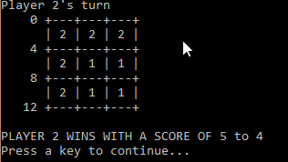

A.I.
In the development of artificial intelligence for our program, we started by making the AI simply place edges in reverse order, starting from the bottom and going left, connecting each dot. Then we gave it a set of conditions to follow. The first condition required the AI to take any boxes it can because if it does, it can go again and continue filling edges from the bottom up. The second condition was to avoid placing an edge that would result in giving up points for free if there are other moves available.
The order of operations goes as follows: good, ok, and bad. The AI takes any boxes made available. Since the player that scores a point gains another turn, the AI can claim all available boxes on a single turn. If no points can be claimed that turn, the AI makes an ok move which simply helps mold the board and does gain or lose points. Lastly, if the AI has no available good or ok moves, the AI moves into a badChoice() 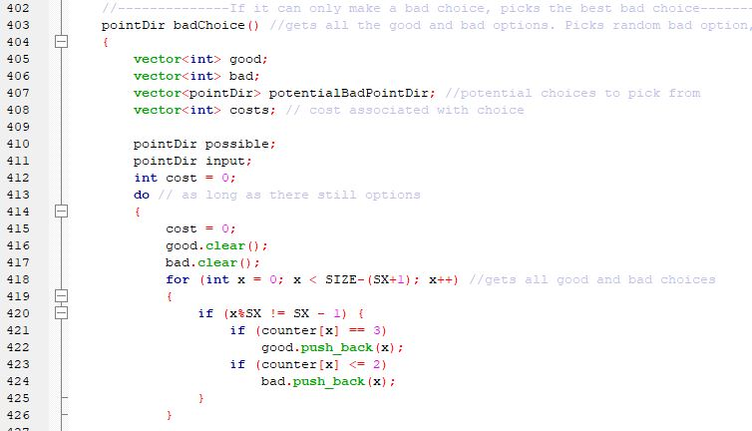function which is essentially a pseudo-minimax function. The AI stores the current state of the board in a temp class, and analyzes each bad move it can make, saving the cost of each in a stack. Then the function outputs the best edge that will result in the lowest cost.

Surprising Discoveries
To our surprise the Artificial Intelligence worked exactly the way we programmed it to. By listing out the conditions that the AI should and shouldn’t do, we designed a sort of greedy application for the AI. After constructing the outlook of the board and seeing the initial responses with the AI, we were shocked at how well it performed after adding a few conditional statements to keep potential moves limited to ones that would benefit the artificially intelligent player. The AI took advantage of any mistakes the player made and continued on filling up the board and creating long maze-like chains.
As far as aesthetics went, the simple approach boded well. Each move was apparent and simple to tell. The grid size was also adjustable using #define statements so the board would adapt to any size or number of dots as long as it was a multiple of m and n.
Input is easy because it is separated into two parts to avoid confusion. The user simply has to input the dot the player wants to select, and add an edge up, down, left or right of the dot to connect two un-joined adjacent dots.
The board shows each of the AI’s moves whenever it gets to go again just in case player needs to make sure the AI is making all legal moves and isn’t cheating in any fashion. Also made verification super easy seeing every move in each separate frame.

Results
The artificial intelligence we created was able to greedily make the best valid move while able to see one move ahead each decision it made regarding long chains. It would select the chain that gave away the least amount of points to the other player so that it could potentially grab the chain with more points resulting in victory. Of course, this generally only works against beginners who don’t know the double-cross strategy where the player taking the long chain can opt to give up the last two boxes in the chain so the other player can take them, go again, and be forced to open up another long chain. Other than that, the AI applies techniques most experienced players would use, and if the board is small, the AI would tie or win every time.
The artificial intelligence chooses where to go in the initial stages of the game based on a randomizer that tests whether or not the edge is valid but also doesn’t fail in the other two conditions which include giving away points and also forgetting to place the fourth edge to complete a box. Whenever it can, the AI will claim points before making any other move, that is generally when the AI starts to adjust its course. The player influences the AI’s decision making when the player forces the AI to take a point, the AI would not refuse and always takes the point. The only way this can be used against the AI is if the player is trying to give away a small block in order to force the AI to open up a large chain of blocks.

Conclusion
In conclusion, the artificial intelligence implemented in this project has the ability to win against any player in a small 9 dot, 4 box board, if not tied. Typically, this board is used for beginners who wish to learn strategy and basically how the game works. The larger the board, the less successful our AI will be; however, against people just learning how to play the game, the AI will easily win. Since the AI is hardcoded to not make any mistakes, it will avoid any moves that give points to the player and always take points that are made up for grabs, so the player cannot take it. The success of our AI provides a good threshold for beginning players that wish to advance to higher and more methodical ways of play.
Our utilization of classes and vectors allowed simple storage for all the dots and edges. Performance is fast due to easy look up of values to determine which edges are filled in and which boxes are claimed. Although the user interface isn’t one where the user can simply click on the edge to select it, selecting the dot by counting from the side number references and which direction the edge extends to, should be easy enough. The game is played using terminal output.
Ways the artificial intelligence can improve include implementing a minimax algorithm that can calculate the best moves in the beginning stages of the game. Of course, the larger the board, the more difficult it will be for the AI to calculate that many steps in advance. It could also be improved if by setting the AI to place edges in a manner where an ideal number of ‘long chains’ is created in order to ensure victory or forcing the player to open the first long chain. Overall, implementing artificial intelligence was a great learning experience for the programmers but also realizing the endless possibilities of what an AI can do.

Acknowledgment
The authors would like to thank Dr. Korzhova and the T.A. at the University of South Florida, Tampa, Florida for creating this interesting opportunity to code and design Artificial Intelligence with the ability to beat the player in a game of Dots and Boxes.

References

- C. C. Abt, Serious Games, Lanham, MD, USA:Univ. Press Amer., 1987.
- T. Dumbleton, J. Kirriemuir, "13 digital games and education", Understanding Digital Games, pp. 223, 2006.
- C. Fairclough M. Fagan B. M. Namee P. Cunningham "Research directions for ai in computer games" Proc. 12th Irish Conf. Artif. Intell. Cogn. Sci. pp. 333-344 2001.
- IC. Girard, J. Ecalle, A. Magnan, "Serious games as new educational tools: How effective are they? A meta-analysis of recent studies", J. Comput. Assisted Learn., vol. 29, no. 3, pp. 207-219, 2013.

